Varadise Agent Platform Systems Analysis and Design
Handover architecture, workflows, deployment and operating model
Version 1.0 | 28 September 2026 | Prepared for system handover
This document explains how the Varadise Agent Platform is structured, how requests move through it, what data and trust boundaries it uses, and what the receiver must verify before accepting operation. It is written as a practical systems analysis and design reference for engineering, security, deployment and support teams.
Document item | Value
System | Varadise Agent Platform
Baseline source commit | a55db265b3462e32acdef210e3e000f48b0e3a66
Source branch | codex/major-revamp-2026-09-25
Primary runtime | Node.js 22 in Docker
Persistence | PostgreSQL 17 with pgvector, or JSON store fallback
Handover package | 01-source and 02-docker-preserved in this folder
Status snapshot | Health OK; schema revision 8121; retrieval 13 documents / 69 chunks; one WhatsApp session captured

Contents
- 1 Executive summary
- 2 Purpose and scope
- 3 Stakeholders actors and permissions
- 4 Functional requirements
- 5 Nonfunctional requirements
- 6 System context
- 7 Use case view
- 8 Logical component architecture
- 9 Docker deployment architecture
- 10 Data model and persistence design
- 11 Agent Chat workflow
- 12 WhatsApp workflow
- 13 File ingestion and retrieval workflow
- 14 Document template and artifact QA workflow
- 15 Message and artifact state model
- 16 API and integration design
- 17 Security and trust boundaries
- 18 Operations backup and restore
- 19 Testing and acceptance
- 20 Risks and hardening recommendations
- 21 Traceability to source files
- 22 Diagram index
- 23 Receiver command appendix

1 Executive summary
Varadise is a coordinator-first platform for version-pinned construction AI experts operating inside protected project boundaries. The control plane provides a browser application, project and deployment administration, retrieval over project documents, direct or Hermes-mediated model execution, document artifact generation, WhatsApp project-group integration, and activity/audit records.
The design separates coordination from model execution. Every message is authorized, resolved to a project and deployment, enriched with scoped context, executed through a bounded provider or Hermes request, and persisted with a manifest revision and hash. Artifacts are rendered from managed templates and pass deterministic report QA before delivery.
The handover is operationally usable when the receiver can restore the preserved Docker package, confirm PostgreSQL and application health, rotate secrets, create named users, verify project and deployment scopes, pair or re-pair WhatsApp groups, test one direct and one Hermes request, and prove that an artifact can be rendered and downloaded.

2 Purpose and scope
This SAD covers the implemented platform represented by the source snapshot and preserved Docker package in the handover folder. It describes design intent, current behavior, interfaces, persistence, deployment, security, operations and acceptance evidence. It includes both the browser control plane and the project WhatsApp bridge.
The document does not replace product policy, provider contracts, project-specific prompt content, legal retention schedules or production network standards. Those are receiver-owned decisions that must be applied after restoration.
In scope | Out of scope
Control-plane SPA, HTTP API, persistence adapters, retrieval, expert deployments | Commercial terms, sales process and marketing collateral
Direct model and Hermes execution paths | Provider account procurement and billing
WhatsApp pairing, group binding, context and delivery acknowledgements | WhatsApp business verification outside the bridge
Document templates, rendering and report QA | Formal certification or regulatory approval
Docker services, volumes, backup and restore | High-availability orchestration not present in the package

3 Stakeholders actors and permissions
The platform uses role-based permissions combined with organization, project and agent allowlists. Administrators receive wildcard access; custom users receive only the permissions and selected scopes assigned to them.
Actor or role | Responsibilities | Primary permissions
Administrator | Bootstrap, users, projects, experts, deployments, connectors and recovery | All seven capabilities; wildcard scope
Project operator | Use assigned experts and inspect project activity | agents.chat, activity.view
Project/file manager | Maintain project files and document context | files.manage, activity.view
Deployment manager | Compile or update pinned deployments and integrations | deployments.manage, connectors.manage
Expert curator | Maintain expert editions and component snapshots | experts.manage
WhatsApp participant | Send a mention or reply in a bound project group | No browser role; bridge applies project binding
Receiver operations team | Restore, rotate secrets, schedule backups and validate health | Host and Docker access

Capability key | Meaning
experts.manage | Create or update expert editions, skills, tools and lessons
projects.manage | Create projects and manage project membership and settings
deployments.manage | Create, compile and activate version-pinned deployments
files.manage | Upload, administer and download project files
connectors.manage | Configure model, network-drive, Hermes and WhatsApp connectors
agents.chat | Submit agent messages and access generated artifacts permitted by deployment scope
activity.view | Read activity and execution records

4 Functional requirements
ID | Requirement | Status / evidence
FR-01 | Authenticate users with password-backed sessions and active-user checks. | Implemented in security.js and server login routes.
FR-02 | Enforce role, organization, project and agent scope on control-plane operations. | Implemented; test coverage includes admin/member boundaries.
FR-03 | Compile immutable deployment manifests from expert editions, pinned components, lessons, templates, channels and execution settings. | Implemented; manifest revision and SHA-256 hash are persisted.
FR-04 | Retrieve project-scoped documents and chunks while respecting deployment/private visibility. | Implemented; retrieval index reports 13 documents and 69 chunks in captured state.
FR-05 | Execute through a direct OpenAI-compatible provider or bounded Hermes request. | Implemented; Hermes runtime modes are local-cli, external and reference.
FR-06 | Require explicit approval for selected tool calls and reject approval bypass. | Implemented in tool approval and Hermes request handling.
FR-07 | Render validated DOCX/PDF/SVG artifacts from managed templates. | Implemented; LibreOffice conversion is a runtime dependency.
FR-08 | Pair WhatsApp sessions, bind groups to projects and deliver text/documents with acknowledgements. | Implemented; receiver must verify captured session health.
FR-09 | Record activity, execution traces, memory events, artifact QA and delivery state. | Implemented in execution and activity records.
FR-10 | Back up and restore state and managed files. | Package includes logical PostgreSQL and file/runtime archives; receiver schedules recurring backups.

5 Nonfunctional requirements
Quality attribute | Design target and current qualification
Security | scrypt password hashes, AES-256-GCM connector secret encryption, HttpOnly cookies, scope checks, bridge tokens, loopback enforcement and shell-safe Hermes CLI.
Isolation | Project and deployment context boundaries; private document retrieval is deployment-aware; files.manage remains a broader project file administration privilege.
Reliability | PostgreSQL revision conflict detection, advisory locking, flush barriers and explicit lifecycle failures. Sessions and reset tokens remain process-local.
Performance | Bounded Hermes envelopes, capped transcript/context sizes and provider timeouts; scale-out behavior is not provided by in-memory sessions.
Operability | Docker Compose package, named volumes, health endpoints, logical dump scripts, checksums and restore guide.
Portability | Direct provider path uses HTTP(S); Hermes can run local CLI, external adapter or reference mode.
Auditability | Execution records include manifest hash/revision, traces, tool calls, memory events, QA findings and delivery acknowledgements.
Usability | SPA navigation covers Overview, Agent Chat, Expert Library, Component Library, Projects, Deployments, Project Files, Platform Settings, User Control and Activity.

6 System context
Users interact through the control-plane browser application or through a WhatsApp group bound to a project deployment. The control plane owns authentication, authorization, orchestration, persistence and delivery decisions. Model providers and Hermes runtimes are external execution dependencies. Project data, runtime sessions and generated files remain in managed storage.
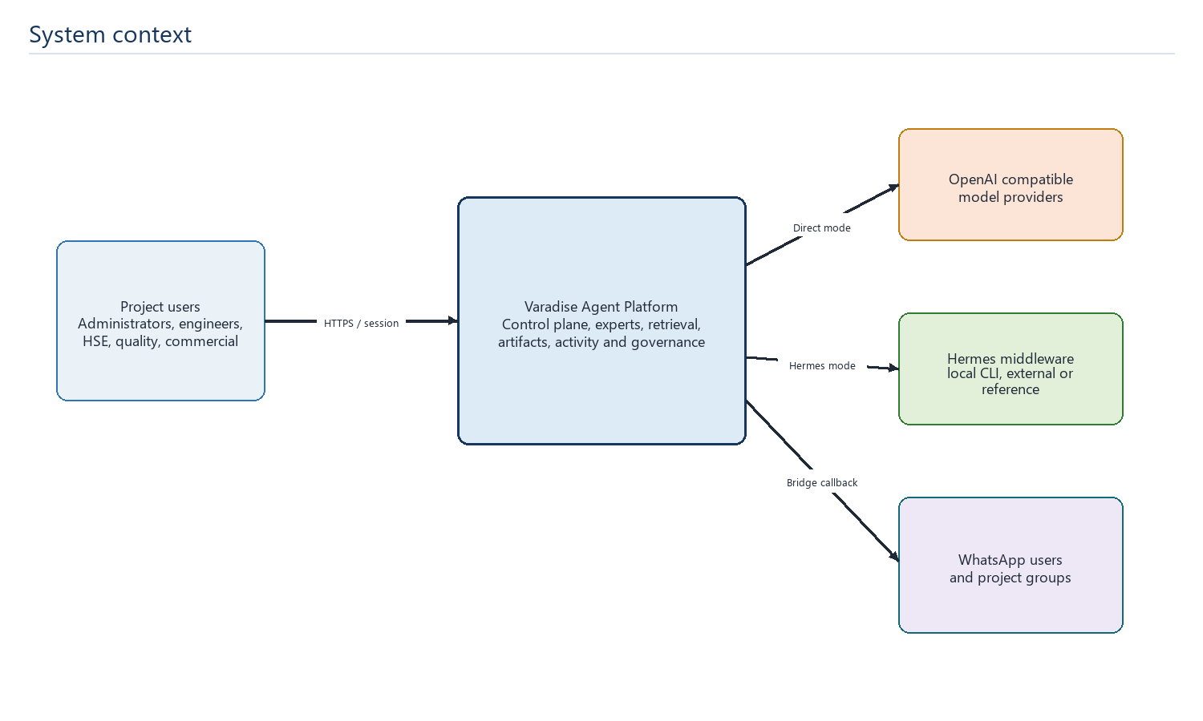
Figure 1. System context and external actors

7 Use case view
The primary receiver-facing use cases are scope-aware authentication, expert chat, file administration, artifact generation, WhatsApp pairing and deployment/connectors management. A use case is complete only when the resulting activity and delivery state are persisted.
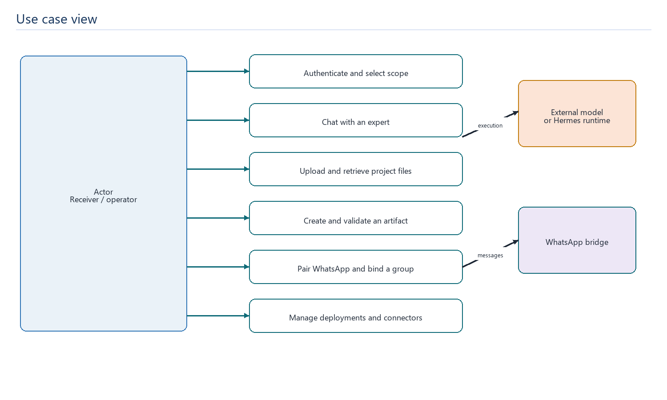
Figure 2. Use case view

8 Logical component architecture
The SPA is a thin client over the control plane. The control plane composes domain contracts and adapters rather than allowing the model provider to define permissions. The store adapter allows the same orchestration logic to use PostgreSQL in the preserved Docker deployment or a JSON store for simpler local operation.
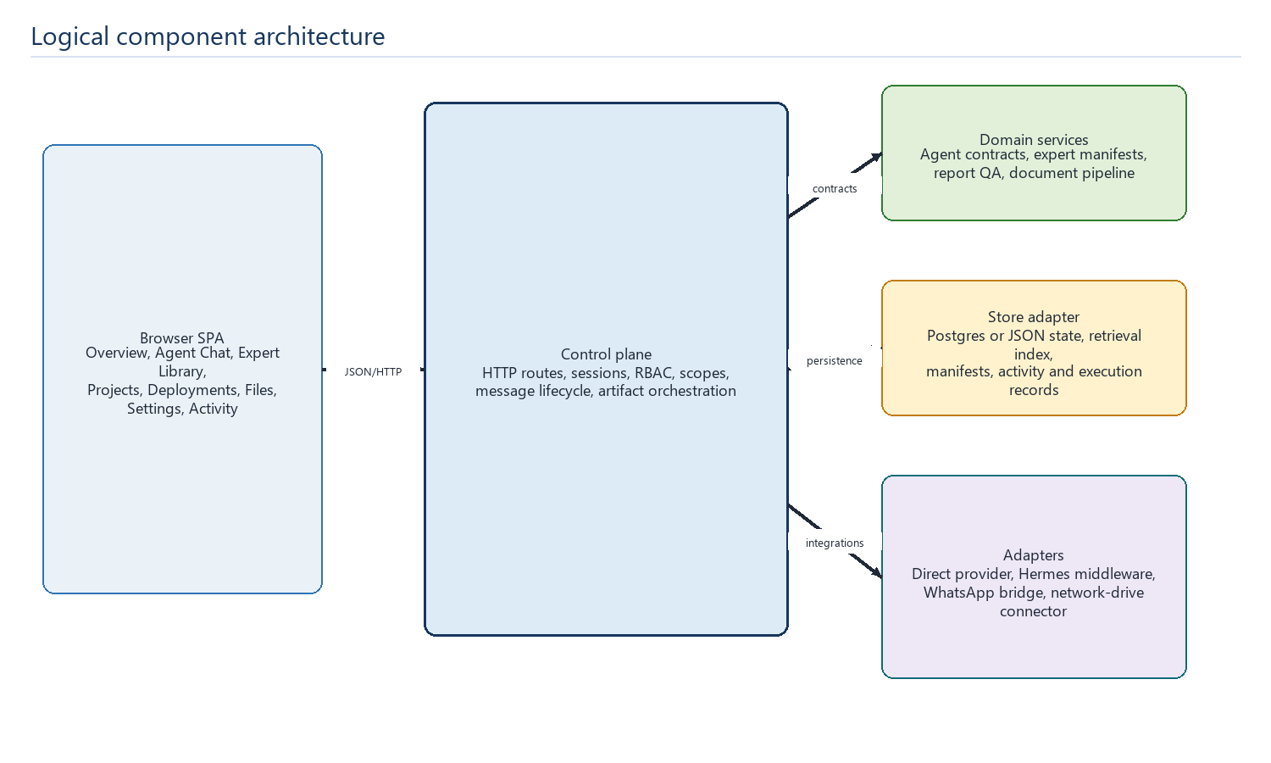
Figure 3. Logical component architecture
Component | Responsibility | Key source locations
SPA | Navigation, forms, chat, files, deployment and settings views | apps/control-plane/public
HTTP control plane | Routes, sessions, RBAC, scopes, workflows, artifacts and WhatsApp callbacks | apps/control-plane/src/server.js
Store adapter | JSON/PostgreSQL state, revisions, locks, retrieval chunks and manifests | apps/control-plane/src/store.js
Security module | Password hashing, secret encryption/decryption and session primitives | apps/control-plane/src/security.js
Retrieval index | Document ingestion, chunking, lexical/vector retrieval and scope filters | apps/control-plane/src/retrieval-index.js
Execution adapters | Direct provider and Hermes envelope/response validation | apps/control-plane/src/agent-execution.mjs
Domain contracts | Message lifecycle, manifest hashing and report QA rules | packages/domain
Bridge processes | Pairing, group filtering, callback delivery and media handling | whatsapp-pair.mjs, project-whatsapp-bridge.mjs, hermes-bot-runtime.mjs

9 Docker deployment architecture
The preserved package runs two Compose services. PostgreSQL exposes host loopback port 5432. The agent-platform container serves the browser/API on port 3000 and Hermes middleware on port 3010. The Dockerfile installs Node 22, LibreOffice Writer, Noto CJK fonts and the Hermes CLI needed for document conversion and local execution.
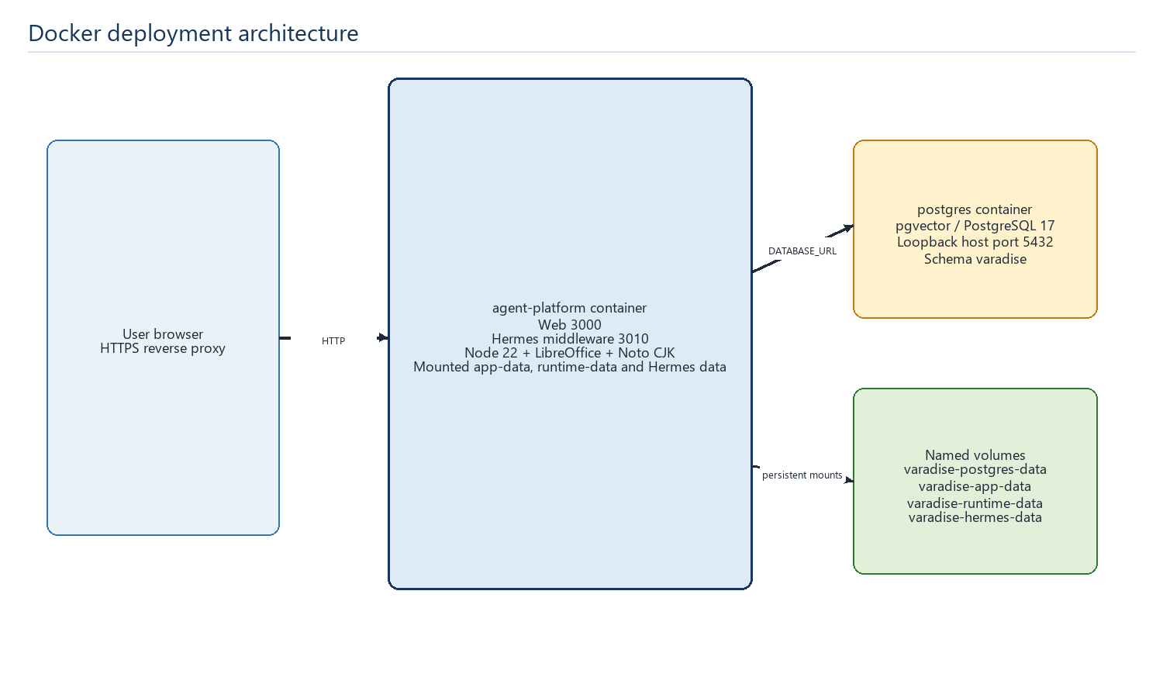
Figure 4. Docker deployment and named volumes
Service or volume | Purpose | Receiver action
postgres | pgvector/PostgreSQL 17 database, schema varadise | Keep port loopback-only; back up logical SQL
agent-platform | Control plane, SPA, artifact pipeline, Hermes middleware | Set secrets and provider configuration; monitor health
varadise-postgres-data | Database physical data | Back up through database tooling; do not copy while live without a safe procedure
varadise-app-data | Managed uploads, generated files and application state | Include in file archive and protect permissions
varadise-runtime-data | WhatsApp sessions and runtime working data | Protect creds.json and archive only through approved process
varadise-hermes-data | Hermes CLI/runtime state | Rotate or replace if receiver changes Hermes identity

10 Data model and persistence design
The logical model centers on organizations, projects, users, experts and editions, deployments, manifests, documents/chunks, messages/executions and artifacts/QA. PostgreSQL stores platform_state, platform_records, document_chunks and agent_manifests under schema varadise. The JSON backend uses atomic local saves and lexical chunk search.
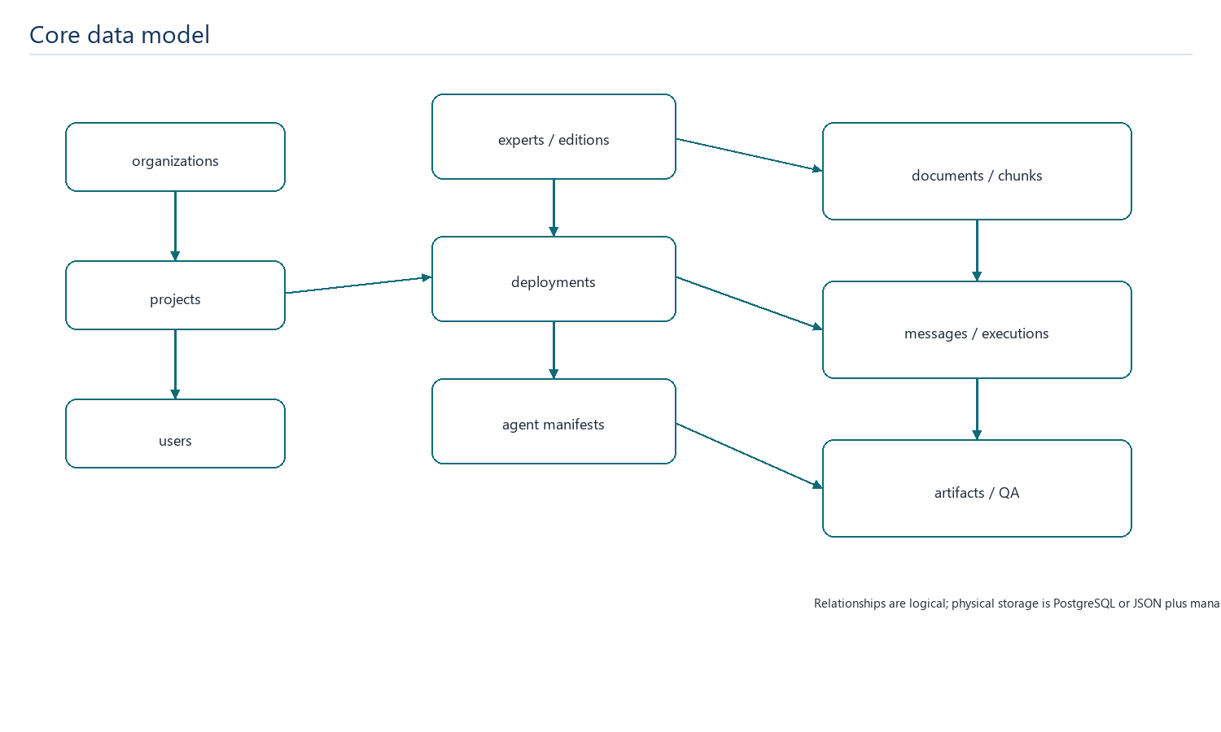
Figure 5. Core entities and logical relationships
Record family | Representative data | Integrity rule
Identity and scope | organizations, projects, users, memberships, allowlists | Every access decision resolves selected IDs against stored scope.
Expert configuration | expert editions, component snapshots, lessons, templates | Deployment stores pinned snapshots and manifest revision/hash.
Conversation | messages, inbound WhatsApp IDs, context transcript, approvals | Lifecycle state is explicit; duplicate inbound IDs are ignored.
Execution | provider request/response, trace, tool calls, memory events | Trace records retain deployment manifest revision/hash.
Documents | managed metadata, chunks, retrieval visibility and folder allowlists | Project and deployment filters are applied before context is returned.
Artifacts | generated files, template revision, QA findings, evidence and delivery state | Empty context or failed validation blocks artifact creation.

11 Agent Chat workflow
Agent Chat is coordinator-first. The control plane receives a message, authenticates the session, resolves project and deployment scope, prepares retrieval and template context, executes through the configured path, and persists the result. Direct mode streams an OpenAI-compatible chat completion. Hermes mode sends a bounded request envelope and validates the response schema.
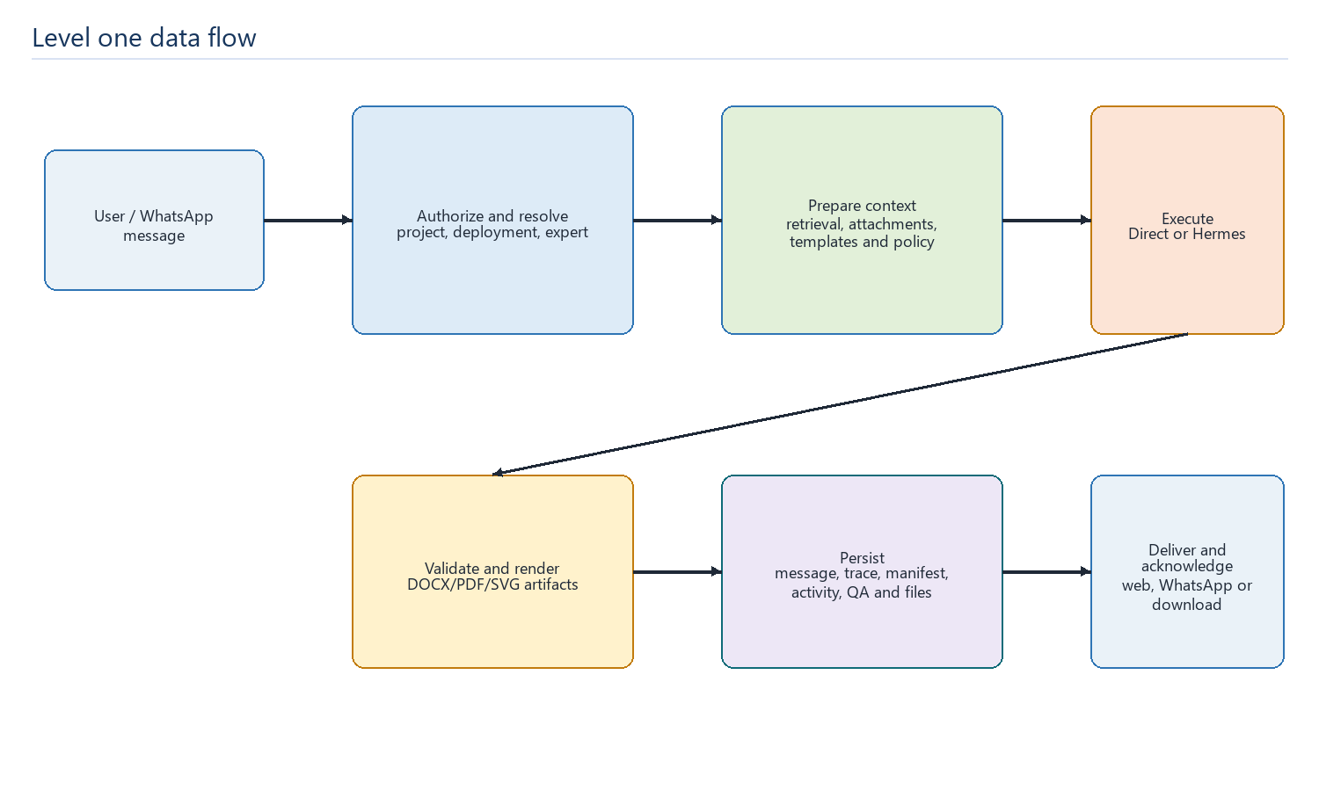
Figure 6. Level one data flow
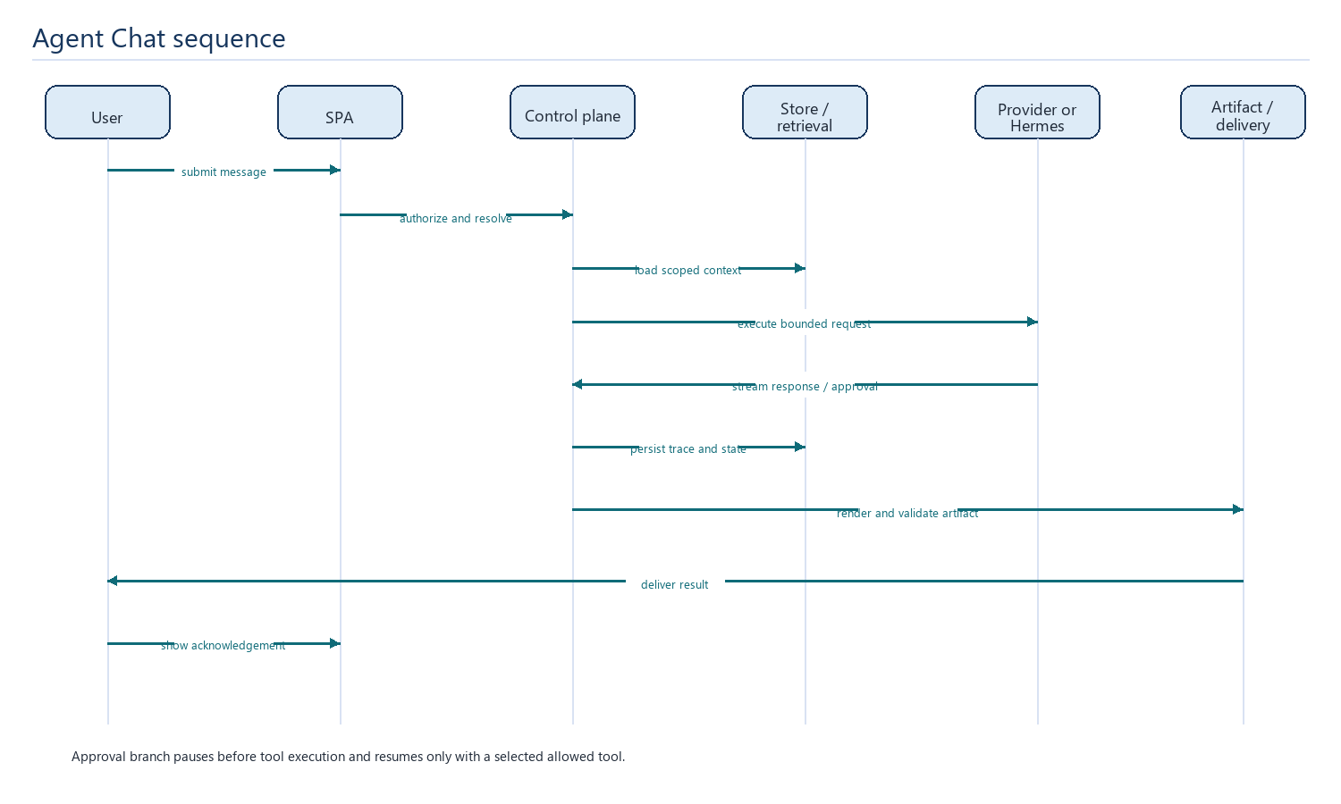
Figure 7. Agent Chat sequence
Stage | Control-plane behavior | Failure recorded when
received | Accept message and normalize attachments | Payload cannot be parsed or attachment metadata is invalid
authorized | Validate session, permission, organization/project/agent scope | User lacks agents.chat or selected scope
deployment_resolved | Load active deployment and manifest revision | No active deployment or requested expert unavailable
context_prepared | Retrieve scoped chunks, images, templates, WhatsApp transcript and activity | Retrieval or context preparation fails
executing | Run direct provider or Hermes request within timeout and tool allowlist | Provider, middleware, schema or timeout failure
awaiting_approval | Pause with concrete permitted tool call | Approval is missing, expired or not allowed
generating_artifact / validating_artifact | Render managed template and run report QA | Missing context, invalid JSON, protected layout or QA failure
delivery_submitted / acknowledged | Send to browser, WhatsApp or download route and persist acknowledgement | Send/download fails or delivery acknowledgement is absent

12 WhatsApp workflow
Each project may have a separate Baileys multi-file session and bridge port. The bridge accepts only local bridge hosts, uses a callback token, forwards group messages, ignores own messages, applies mention/reply policy, bounds image and voice inputs, and records delivery acknowledgements. The control plane binds verified WhatsApp groups to a project deployment and deduplicates message IDs.
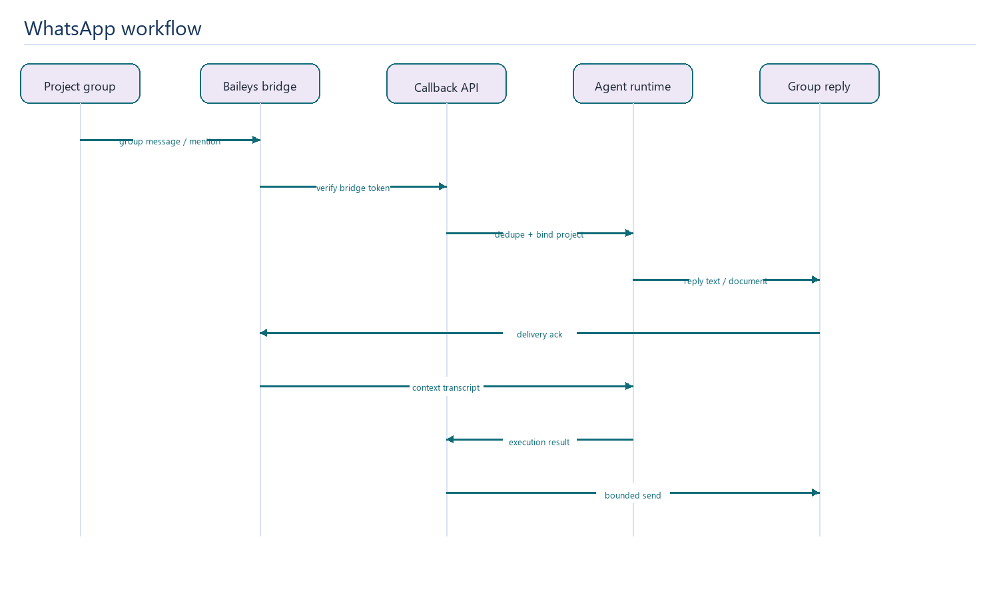
Figure 8. WhatsApp project-group workflow
Control | Behavior
Group binding | Only a verified @g.us group bound to a project deployment is accepted.
Message selection | Mentions, replies to the agent and interactive selections can trigger processing; captionless voice is suppressed by policy.
Context | Optional project/group transcript is retained for configured hours and bounded by message count and character limit.
Media | Image and voice limits are enforced by the bridge; inbound attachments are passed as bounded context.
Delivery | Text, interactive selections and documents are sent through the bridge; callback failures produce a bounded failure message.
Session lifecycle | Pairing allocates a per-project port and canonical session path; logged-out sessions stop.

13 File ingestion and retrieval workflow
Uploaded files are stored below a managed data root after basename sanitization and path containment checks. Network-drive connectors resolve approved roots and subpaths with realpath containment and skip symlinks. Documents are indexed into chunks and retrieved with project/deployment visibility rules. A production receiver should add explicit multipart per-file and aggregate quotas because the inspected multipart route does not show a full file-size quota.
Step | Design
Ingest | Accept body or multipart metadata, normalize filename, write managed file with restrictive permissions.
Extract | Parse supported document text and images; preserve source metadata and project association.
Chunk | Create retrieval chunks and persist them in document_chunks or the JSON index.
Filter | Apply project boundary, deployment/private visibility and optional folder allowlist.
Retrieve | Combine lexical/vector retrieval with attachment and conversation context.
Use | Include only retrieved material allowed by the active manifest and prompt policy.

14 Document template and artifact QA workflow
Template selection prefers an exact or distinctive managed template. Ambiguous compatible templates require explicit confirmation; an invalid template ID is rejected. The provider must return the exact template labels and structured JSON and may not invent signatures, approvals or evidence. The renderer writes only to configured value targets.
Report QA validates deterministic metadata, fields, tables, required rows and columns, narrative length, image targets and protected layout labels. Artifacts are rendered to DOCX, optionally converted to PDF through LibreOffice, and stored as private generated files linked to the project, deployment, template revision, QA findings and evidence.
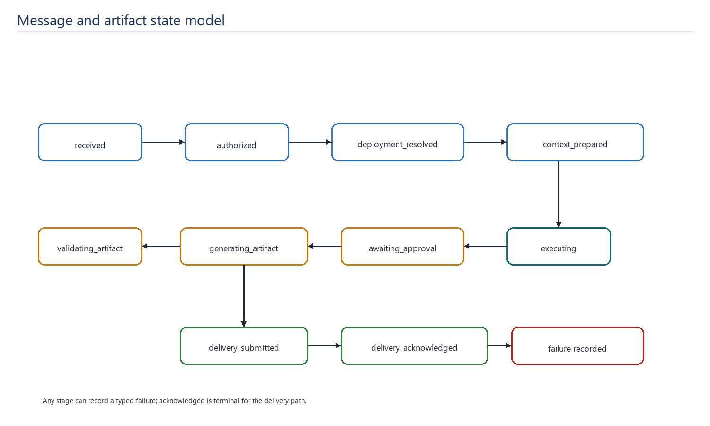
Figure 9. Message and artifact state model

15 Message and artifact state model
The lifecycle is explicit and auditable. The normal path is received, authorized, deployment_resolved, context_prepared, executing, then either awaiting_approval or generating_artifact, followed by validating_artifact, delivery_submitted and delivery_acknowledged. Authorization, context, execution, artifact, validation and delivery failures are recorded as typed failures without silently skipping the failed stage.

16 API and integration design
Interface | Purpose | Boundary and control
Browser to control plane | SPA JSON/HTTP routes for auth, chat, projects, files, deployments, settings and activity | Session cookie, RBAC and selected scope validation
Control plane to PostgreSQL | Store adapter and retrieval persistence | Schema varadise, pool timeout, advisory lock and revision conflict detection
Control plane to direct provider | OpenAI-compatible /chat/completions SSE | HTTP(S) URL validation, bearer key decryption and timeout; egress policy remains operational
Control plane to Hermes | Bounded JSON envelope and validated response | Tool allowlist, approval gate, max request bytes, timeout and retry policy
Bridge to control plane | Local callback endpoints for inbound, pairing and delivery | Loopback host check plus X-Varadise-Bridge-Token
Control plane to network drive | Approved root/subpath connector | Realpath containment and symlink skip
Control plane to artifact renderer | Template renderer and LibreOffice conversion | Managed value targets, QA and private file permissions

17 Security and trust boundaries
The strongest boundary is the control plane: model output is treated as untrusted content and cannot expand permissions, deployment scope or tool allowlists. Connector keys are encrypted with AES-256-GCM using an app-secret-derived key. Passwords use scrypt with random salts. Sessions use random bearer tokens in HttpOnly cookies and active-user checks.
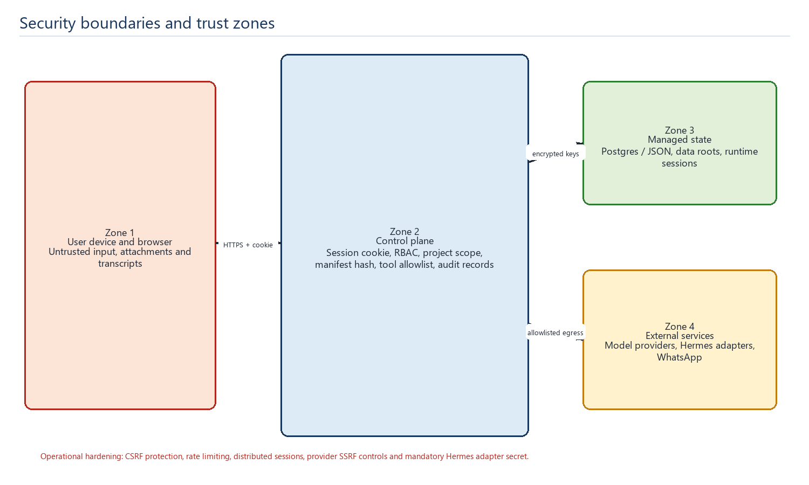
Figure 10. Security trust zones and controls
Control area | Implemented | Receiver hardening
Authentication and secrets | scrypt passwords, AES-256-GCM connector secrets, loopback-only reset request | Use an external secrets manager, rotate bootstrap and connector secrets, enable TLS
Authorization | Role permissions plus organization/project/agent allowlists | Review least privilege after users and projects are recreated
Project data isolation | Scoped retrieval, deployment/private visibility, managed paths | Add multipart quotas and test all connector roots
Execution safety | Bounded envelopes, allowed tools, approval bypass rejection, shell-safe CLI | Constrain egress and provider network access
Bridge safety | Loopback bridge host check, callback token, per-project sessions and dedupe | Set Hermes adapter secret; keep ports private; verify group bindings
Session resilience | Idle timeout and active-user checks | Use shared session storage before horizontal scaling
Web threats | HttpOnly/SameSite cookies | Add CSRF protection and login rate limiting before internet exposure
Audit | Execution traces, manifest hashes, activity and QA findings | Export immutable/WORM audit logs if required by policy

The source review did not evidence explicit login rate limiting, MFA, centralized secrets management, immutable audit storage, a CSRF token, distributed sessions or a DNS/private-IP SSRF denylist for provider URLs. Treat these as receiver-owned production controls before public exposure.

18 Operations backup and restore
The preserved Docker package contains Compose files, environment examples, a logical PostgreSQL snapshot, data/runtime archives, checksums and restore scripts. Restore should be performed into an isolated receiver workspace, followed by health, schema, retrieval, conversion and bridge checks before any project users are invited.
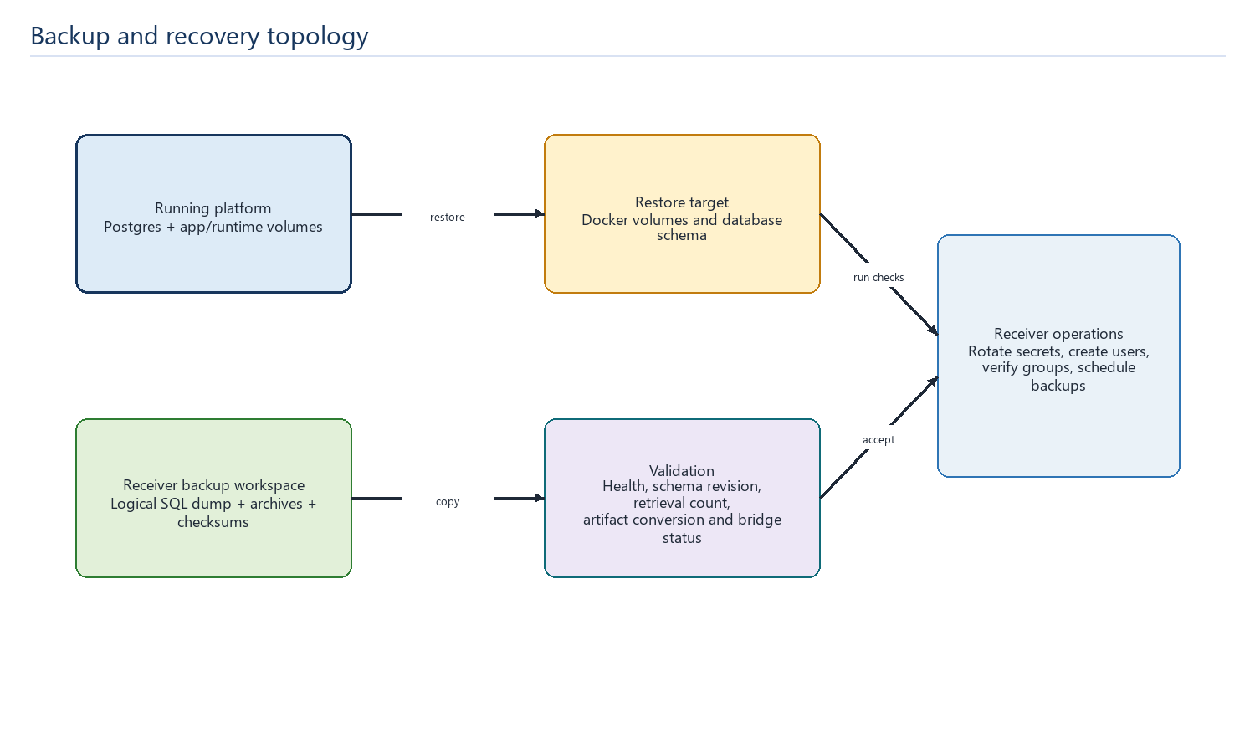
Figure 11. Backup and recovery topology
Operation | Receiver procedure
Restore source | Copy 01-source and 02-docker-preserved to a controlled workspace; inspect HANDOVER.md and RESTORE.md.
Configure | Create a receiver-owned .env from .env.example; set APP_SECRET, database credentials, provider keys, Hermes secret and trusted proxy settings.
Start | Run docker compose up -d --build from 02-docker-preserved/docker. Keep PostgreSQL host binding loopback-only.
Restore database | Use the supplied logical restore script and confirm schema varadise revision.
Restore files | Restore app-data, runtime-data and Hermes data with correct ownership and permissions.
Validate | Check /health, /api/health or equivalent, retrieval counts, DOCX-to-PDF conversion, Hermes /health and WhatsApp session status.
Operate | Create users, rotate bootstrap credentials, verify scopes, schedule database and file backups, and document provider/WhatsApp ownership.

19 Testing and acceptance
Acceptance should prove both the happy path and the isolation path. Existing tests cover user access boundaries, password change/reset, last-admin protection, QR pairing, per-project sessions, bridge-token rejection, dedupe, context, group routing and attachment delivery. The receiver should rerun the relevant suite after restoring the handover package and add environment-specific checks.
Test ID | Acceptance check | Pass evidence
AT-01 | Admin login and custom-user scope | Admin reaches all permitted views; custom user cannot access an unassigned project or expert.
AT-02 | Direct Agent Chat | Message reaches executing and delivery acknowledgement with execution trace.
AT-03 | Hermes Agent Chat | Hermes health is ready; bounded request returns validated response; unlisted tool is rejected.
AT-04 | Approval gate | A tool call pauses for approval and resumes only after the selected permitted tool is approved.
AT-05 | Document retrieval | A project document is retrieved for the assigned deployment; another project document is excluded.
AT-06 | Artifact QA | Managed template renders DOCX and PDF; failed required field blocks creation.
AT-07 | WhatsApp | Bound group mention creates one message; duplicate inbound ID does not create a second execution; document reply is acknowledged.
AT-08 | Restore | Database and files restore from package; health, revision and retrieval counts match the captured baseline or approved delta.
AT-09 | Security negative tests | Bridge token, project scope, tool allowlist, path containment and approval bypass protections reject invalid requests.

20 Risks and hardening recommendations
Risk | Impact | Recommendation | Priority
Process-local sessions | Restart or replica can invalidate sessions and make users appear logged out. | Use a shared session store before horizontal scaling. | High
Optional Hermes adapter secret | External middleware can be reachable without adapter authentication if secret is empty. | Set a non-empty secret and bind middleware to loopback/private network. | High
Provider SSRF policy | HTTP(S) validation alone does not deny private or rebinding targets. | Enforce DNS/IP egress policy in reverse proxy or network layer. | High
Multipart upload quota | Large multipart files could consume disk or processing capacity. | Add per-file and aggregate quotas plus content-type and timeout controls. | High
CSRF and login abuse | Cookie-authenticated state changes require browser threat controls. | Add CSRF tokens and login rate limiting before internet exposure. | High
Runtime credentials | WhatsApp creds and connector keys are sensitive operational state. | Use protected storage, rotation, least privilege and backup encryption. | High
LibreOffice dependency | Artifact PDF conversion fails if the runtime package is incomplete. | Keep the bundled image and include conversion smoke test in deployment acceptance. | Medium
Reference Hermes mode | Reference mode is intentionally non-executing. | Document it as a stub and select local-cli or external for production. | Medium
Operational audit retention | Application activity is not automatically immutable/WORM. | Export and retain audit records under receiver policy. | Medium

21 Traceability to source files
Design topic | Primary implementation reference
Browser modules and navigation | apps/control-plane/public/app.js and styles.css
HTTP routes, sessions, RBAC, message and artifact orchestration | apps/control-plane/src/server.js
Persistence and retrieval storage | apps/control-plane/src/store.js and retrieval-index.js
Password and connector secret handling | apps/control-plane/src/security.js
Direct and Hermes execution | apps/control-plane/src/agent-execution.mjs, hermes-agent-middleware.mjs, hermes-cli-adapter.mjs
WhatsApp pairing and bridge | whatsapp-pair.mjs, project-whatsapp-bridge.mjs, hermes-bot-runtime.mjs, whatsapp-message-policy.mjs
Message lifecycle and report QA | packages/domain/agent-contracts.mjs and report-qa.mjs
Docker runtime | Dockerfile, compose.yaml and 02-docker-preserved/docker
Handover recovery | 02-docker-preserved/HANDOVER.md, RESTORE.md, scripts and archives

22 Diagram index
Figure | Diagram | Purpose
1 | System context | Architecture or workflow view included in this SAD
2 | Use case view | Architecture or workflow view included in this SAD
3 | Logical component architecture | Architecture or workflow view included in this SAD
4 | Docker deployment architecture | Architecture or workflow view included in this SAD
5 | Core data model | Architecture or workflow view included in this SAD
6 | Level one data flow | Architecture or workflow view included in this SAD
7 | Agent Chat sequence | Architecture or workflow view included in this SAD
8 | WhatsApp workflow | Architecture or workflow view included in this SAD
9 | Message and artifact state model | Architecture or workflow view included in this SAD
10 | Security boundaries and trust zones | Architecture or workflow view included in this SAD
11 | Backup and recovery topology | Architecture or workflow view included in this SAD

23 Receiver command appendix
Commands below are representative Windows PowerShell commands. Run them from the handover folder and adapt Docker Desktop or shell syntax to the receiver host.
Task | Command or action
Inspect package | Get-ChildItem .\01-source; Get-ChildItem .\02-docker-preserved
Start preserved Docker package | Set-Location .\02-docker-preserved\docker; Copy-Item .env.example .env; docker compose up -d --build
Check services | docker compose ps; docker compose logs --tail=200 agent-platform; docker compose logs --tail=200 postgres
Check database | docker compose exec postgres pg_isready -U $env:POSTGRES_USER -d $env:POSTGRES_DB
Restore logical snapshot | Use scripts\restore-logical-postgres.ps1 or the receiver-approved equivalent described in RESTORE.md
Check application | Open http://localhost:3000 and run the receiver health checks in the handover guide
Check Hermes | Invoke-WebRequest http://localhost:3010/health; require a ready response before Hermes acceptance
Verify source baseline | Read 01-source\BASE-COMMIT.txt and 01-source\VERIFICATION.txt; compare SHA-256 manifests
Back up after acceptance | Run the supplied backup scripts and store encrypted copies with checksums and date

The receiver should record the actual restored image digest, environment ownership, secret rotation date, database revision, retrieval count, WhatsApp session state and acceptance test results in its own operations log.

